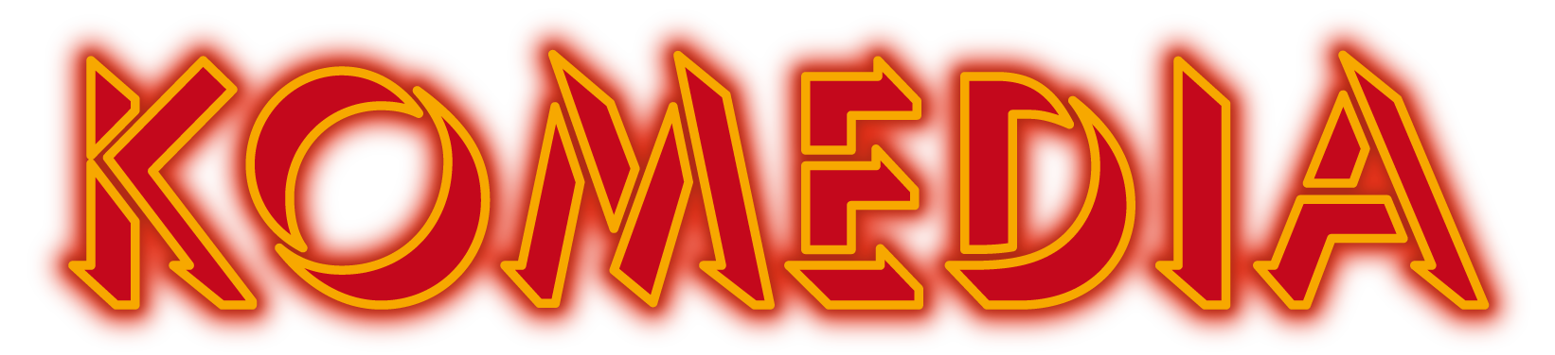

**Accessibility Policy**

|  |  |
| --- | --- |
|  | Komedia aims to be accessible to all.  Customers who require the support of a companion are entitled to one free ticket with their purchased ticket.  These tickets are available by phone 01273 647100 or in person at the Box Office. |
|  | If early entrance to the venue is required please may we ask you to contact admin@komedia.co.uk so we can make suitable arrangements ahead of your visit.  If you use a wheelchair or have special access requirements please call 01273 647100 (12noon – 6pm) or email <mailto:tickets@komedia.co.uk> so we make the necessary arrangements for you. |
|  | Assistance Animals are welcome in the venue and bar. |
|  | There is lift access to the two performance spaces.  Both spaces are accessible via stairs and our lift. Komedia’s main entrance is ground level on Gardner Street (level 2 within the building). |
|  | There are fully accessible disabled toilets for Komedia Downstairs and the Studio. |
|  | The bars in our performance spaces have low level access for wheelchair users.  The downstairs performance space has a Sennheiser infra-red Hearing System. Please let box office know if you would like to use the system when you are booking so they can reserve you a suitable seat and a headset. |
| **Booking your event** | |
|  | Our licence specifies the maximum number of wheelchair users that can be accommodated on each floor. We advise wheelchair users to book in advance to guarantee access and in order that we can reserve a suitable table for the party. |
|  | Visually impaired customers are advised to inform us when booking tickets in order that we can reserve a table near the front for the party. |
| **Information** | |
|  | Large print menus and wine lists are available on request. |
|  | Food & Drink Menus are available in braille. |
| **Access to the specific Venues**  Click [here](https://my.matterport.com/show/?utm_source=ep&utm_medium=body&utm_campaign=linktrack&utm_content=wysiwyg&m=AbAVHgNisTm) for an interactive 3D Map of Komedia Brighton. | |
|  | **Events in Komedia Studio**  The Studio is located on level 1. There is one flight of stairs (9 steps), and also a lift.  The toilets are located back on level 2 which is the same level as the main entrance to Komedia. |
|  | **Events in the Komedia Downstairs**  There are two flights of stairs (18 steps) down to the Basement. There is also a lift.  The toilets are located to the left-hand side of the room when looking at the stage. |
|  | **Leaving the Venue**  When leaving the venue please use lift or stairs back to the main entrance on Gardner Street.  Click [here](https://my.matterport.com/show/?utm_source=ep&utm_medium=body&utm_campaign=linktrack&utm_content=wysiwyg&m=AbAVHgNisTm) for an interactive 3D Map of Komedia Brighton.  Staff will be happy to assist you if required. |
|  | **Medical Requirements**  If any medication or essential food and drink are required at our events, we are happy to help.  Just let us know so we can tell our staff team working on the night.  If this isn’t our possible and staff have been made aware that we are happy for customer’s own food to be brought in to the venue when it’s important for someone’s health. |
|  | **Strobe Lighting Policy**  Strobe Lighting may be used for live music events and club nights.  If we are told in advance that a customer is attending who may be affected by the use of strobes, we won’t use them.  Sometimes the artist won’t allow us to change this.  If heavy strobe lighting is being used warning signs will be placed around the venue. |
|  | **Sound Levels**  Some gigs are meant to be loud but they should also be safe.  Komedia operates a Noise at Work policy from the current Health and Safety Executive (HSE) guidelines.  For this reason we keep a close eye on decibel levels and we also have ear plugs behind the bar for every event. |